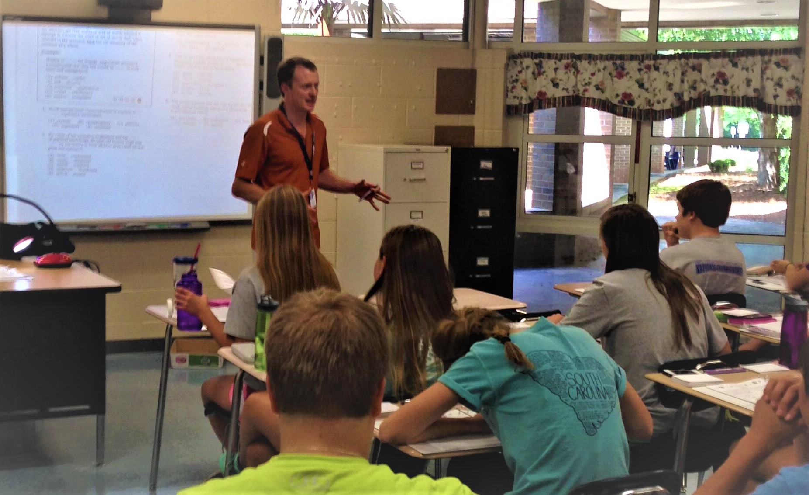  01/23/20  SAt/ACT Workshop  Do you need help with the SAT/ACT? Are you looking to boost your score? Come join Tim Anderson on Thursday, January 23rd in the Lecture Hall from 8:15-3:40 and discover the success that thousands of his students across South Carolina have experienced. This intensive workshop will cover the content of the SAT/ACT’s Math, Reading, and English tests as well as overall test-taking strategy/process. To register, please see Mrs. Baxter in B201.  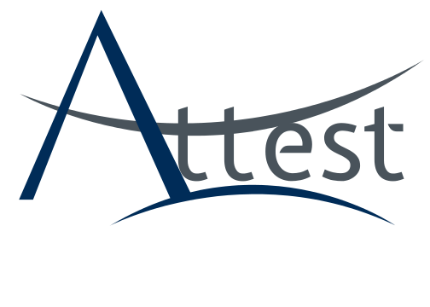 | Learn what you need to know.  ────  Understand how you are being tested.  ────  Get the score you want!  ────  $30 Full School Day  ────  Register with Mrs. Baxter (B201)  Attest llc  109 Old Chapin Rd.  Lexington, SC 29072  (803) 403-5080  www.AttestLLC.org

